June 22, 2018
Dear EVCS Math Students and Families,
Hello, summer! You have worked very hard in 6th grade learning new math skills and perfecting older ones. To not lose progress on all of the hard work you have made during the 2017-2018 school year, you will have a summer math assignment to work on over the next two months so that you are ready to jump into 7th grade math next year!
Below you will find specific directions for the math summer work. Each student must complete the assignment, which will be due on Friday, September 7th, 2018. Failure to turn in this assignment on September 7th will result in a silent lunch for each additional day that the assignment is late.
7th Grade Math Summer Work
- Students are to complete each problem in the packet.
- Students must SHOW ALL WORK that leads to their answer. Any question that contains no work and/or explanation will result in an incomplete assignment and a silent lunch will be given.
- If a student does not know how to complete a problem, they must circle the part they do not understand in the problem and identify what they do not understand using a written statement. Failure to complete this step for those problems will result in an incomplete assignment.
- The following links can be used to help students review concepts related to questions:
  - https://www.khanacademy.org
  - https://artofproblemsolving.com/videos/prealgebra
  - https://www.wyzant.com/resources/lessons/math
  - https://www.youtube.com
Please feel free to email me (Ms. Clifford) at aclifford@elmwoodvillageschool.org if you have any questions regarding this assignment.
Have a safe, happy, and relaxing summer!
Ms. Anna Clifford
7th & 8th Grade Math Teacher
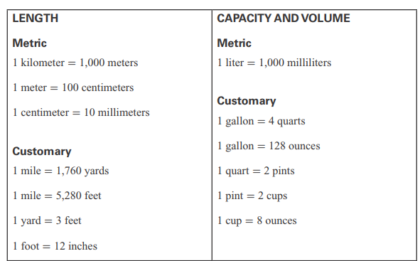
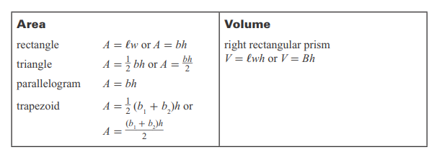

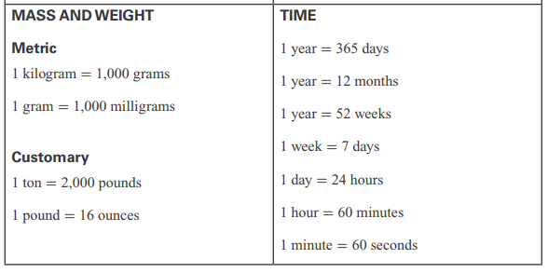

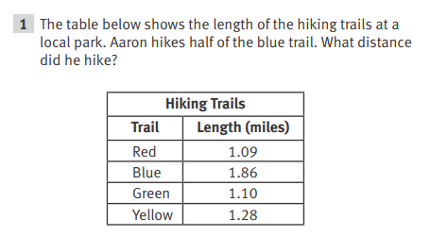
Show Your Work / Explain Your Reasoning:

Answer: ___________________________

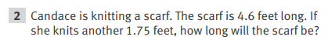

Show Your Work / Explain Your Reasoning:

Answer: __________________________

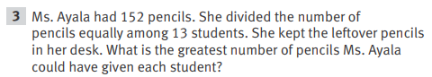

Show Your Work / Explain Your Reasoning:

Answer: ___________________________

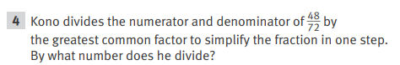
Show Your Work / Explain Your Reasoning:

Answer: ___________________________

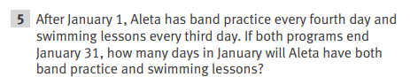

Show Your Work / Explain Your Reasoning:

Answer: ___________________________

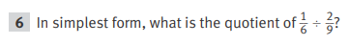
Show Your Work / Explain Your Reasoning:

Answer: ___________________________

Show Your Work / Explain Your Reasoning:

Answer: ___________________________

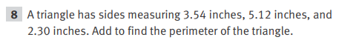

Show Your Work / Explain Your Reasoning:

Answer: ___________________________

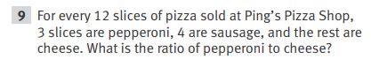
Show Your Work / Explain Your Reasoning:

Answer: ___________________________

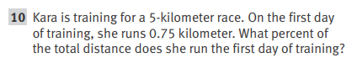
Show Your Work / Explain Your Reasoning:

Answer: ___________________________
If it’s JULY 21 and you are done with #1 - #10, you are on track! If not…you have some catching up to do…
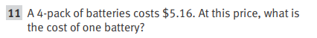

Show Your Work / Explain Your Reasoning:

Answer: ___________________________

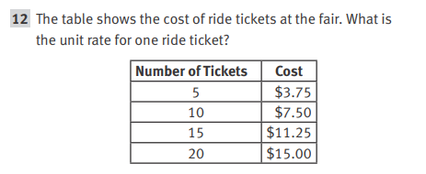
Show Your Work / Explain Your Reasoning:

Answer: ___________________________

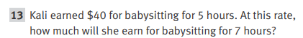

Show Your Work / Explain Your Reasoning:

Answer: ___________________________

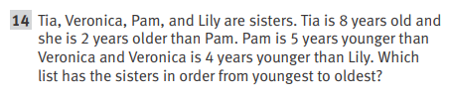
Make your own list of sisters from youngest to oldest.

Show Your Work / Explain Your Reasoning:

Answer: ___________________________

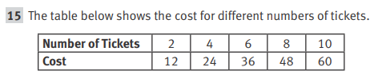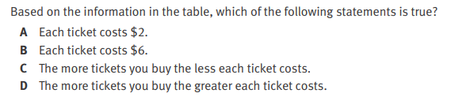

Show Your Work / Explain Your Reasoning:

Answer: ___________________________

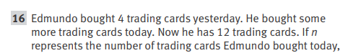
write an equation to show the total number of cards Edmundo
accumulated over the past two days.

Show Your Work / Explain Your Reasoning:

Answer: ___________________________

Simplify the expression by using the distributive property.

Show Your Work / Explain Your Reasoning:

Answer: ___________________________

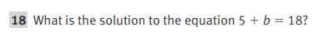

Show Your Work / Explain Your Reasoning:

Answer: ___________________________

Write an inequality that represents p, the amount of time Miguel practiced.

Show Your Work / Explain Your Reasoning:

Answer: ___________________________

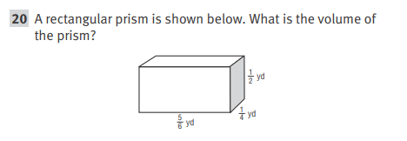

Show Your Work / Explain Your Reasoning:

Answer: ___________________________
If it’s AUGUST 11 and you are done with #1 - #20, you are on track! If not…you have some catching up to do…
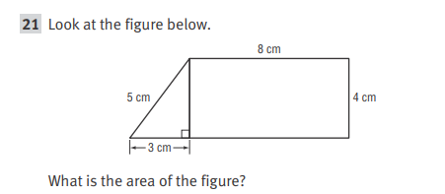

Show Your Work / Explain Your Reasoning:

Answer: ___________________________

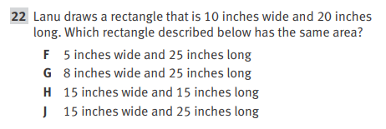
Show Your Work / Explain Your Reasoning:

Answer: ___________________________

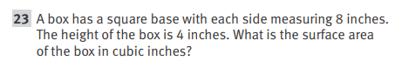

Show Your Work / Explain Your Reasoning:

Answer: ___________________________

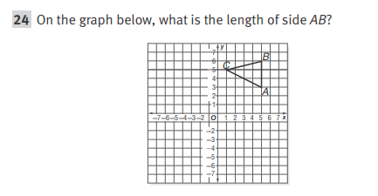
Show Your Work / Explain Your Reasoning:

Answer: ___________________________

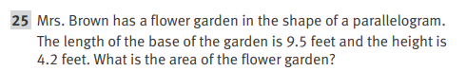

Show Your Work / Explain Your Reasoning:

Answer: ___________________________

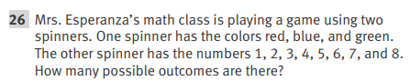

Show Your Work / Explain Your Reasoning:

Answer: ___________________________

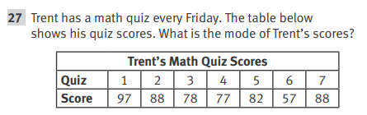

Show Your Work / Explain Your Reasoning:

Answer: ___________________________

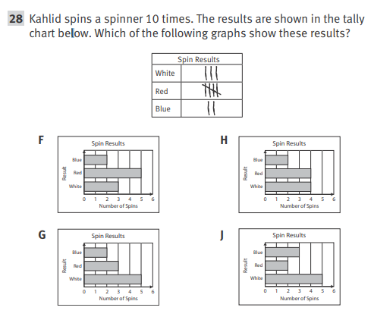
Explain Your Reasoning:

Answer: ___________________________

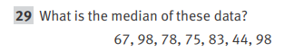

Show Your Work / Explain Your Reasoning:

Answer: ___________________________

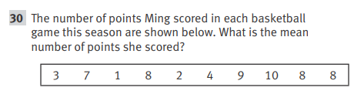

Show Your Work / Explain Your Reasoning:

Answer: ___________________________

Finish me by September 6th…I am due on Friday, September 7th!

